Lab Activity 02 Worksheet

After completing the requested tasks place screen shots in the sections below.

Parts 1, 2 and 4

Folder PATH listing for volume Windows-SSD
Volume serial number is 7EFB-956C
C:.
| index.txt
|
+---Lab Work
| Formula Practice.xlsx
|
+---Lecture Notes
| Week 1 Notes.docx
|
\---Teamwork
Presentation.pptx

C:\Users\l\OneDrive\Documents\CST8118 Notes for VasukumarPatel>

Part 3
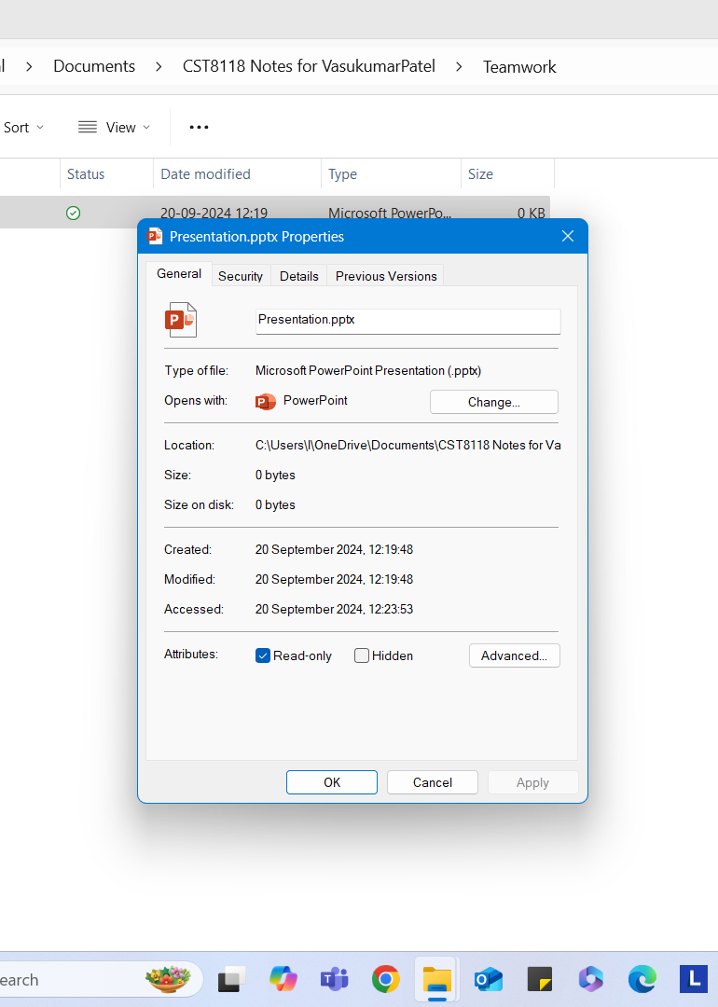

Part 5
Operating System Updates screen shot.
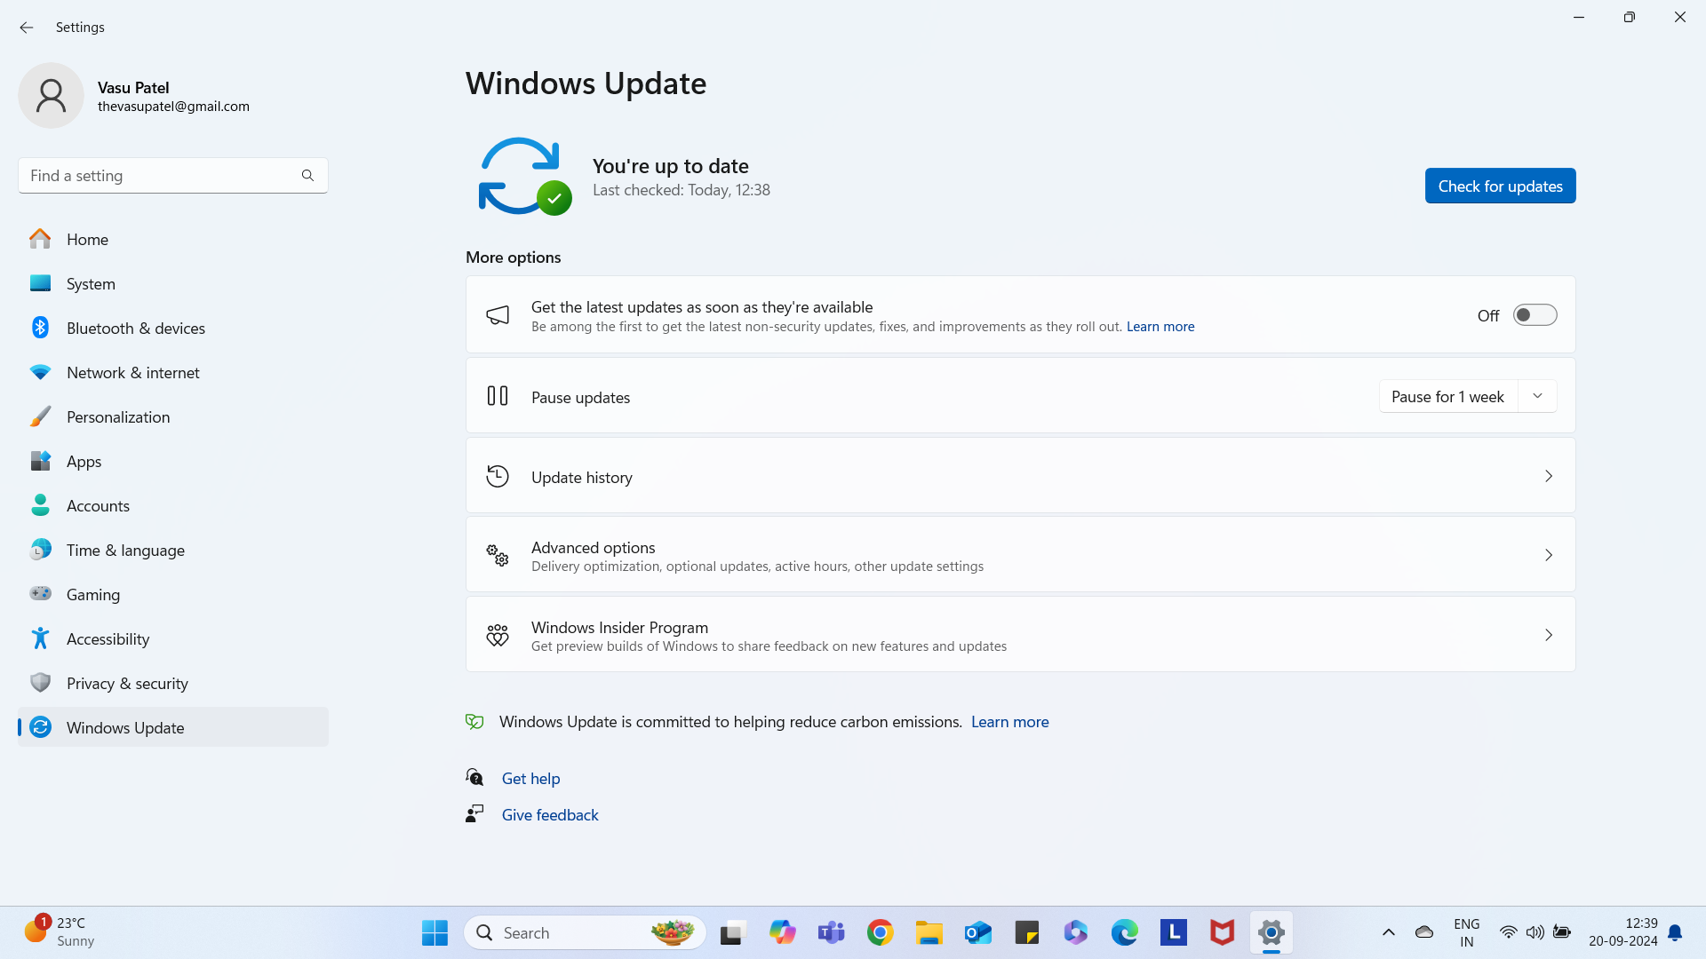
Antivirus Software Updates screen shot.
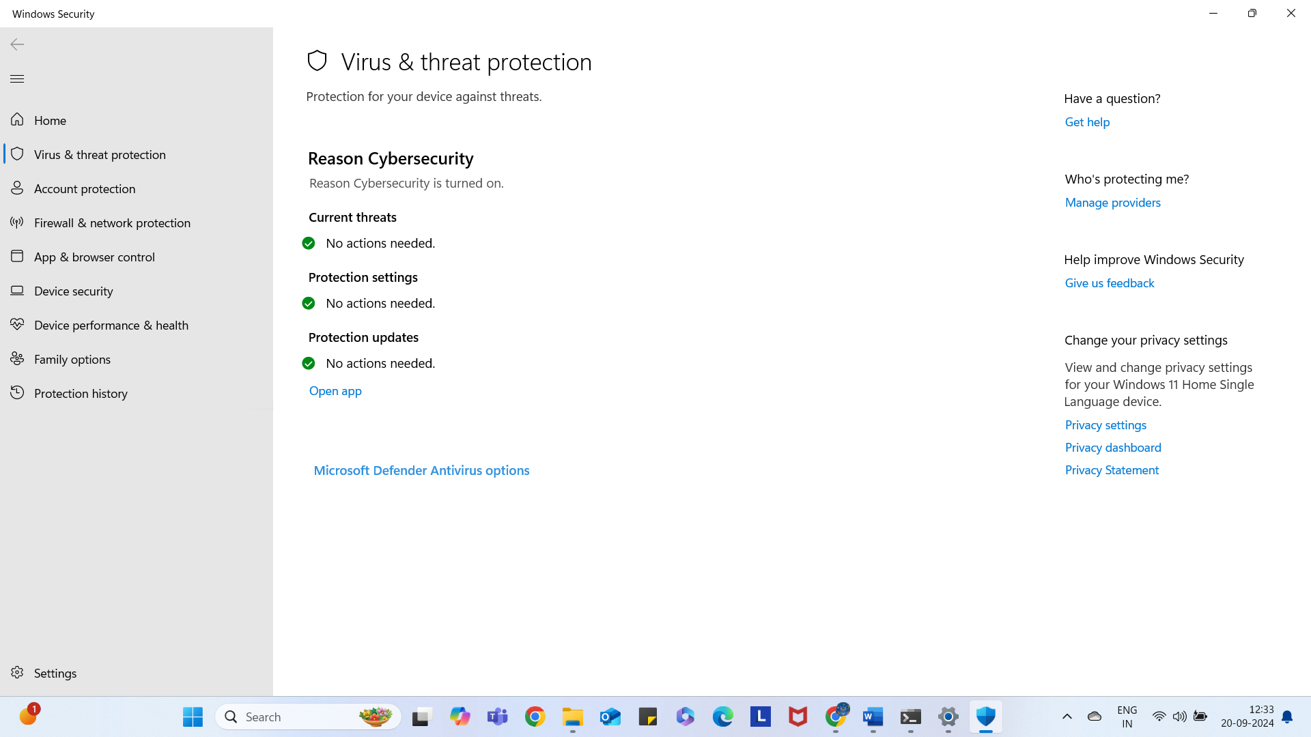

Reminder: Upload the index.txt file with the tree command results, to Brightspace, along with your worksheet file.

